1. 
2. 
3. 
4. 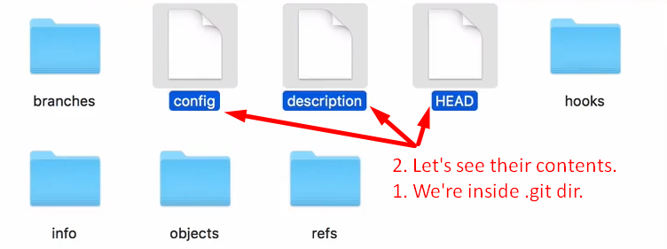
5. **NOTE**:
   1. Git has its own file system.
6. 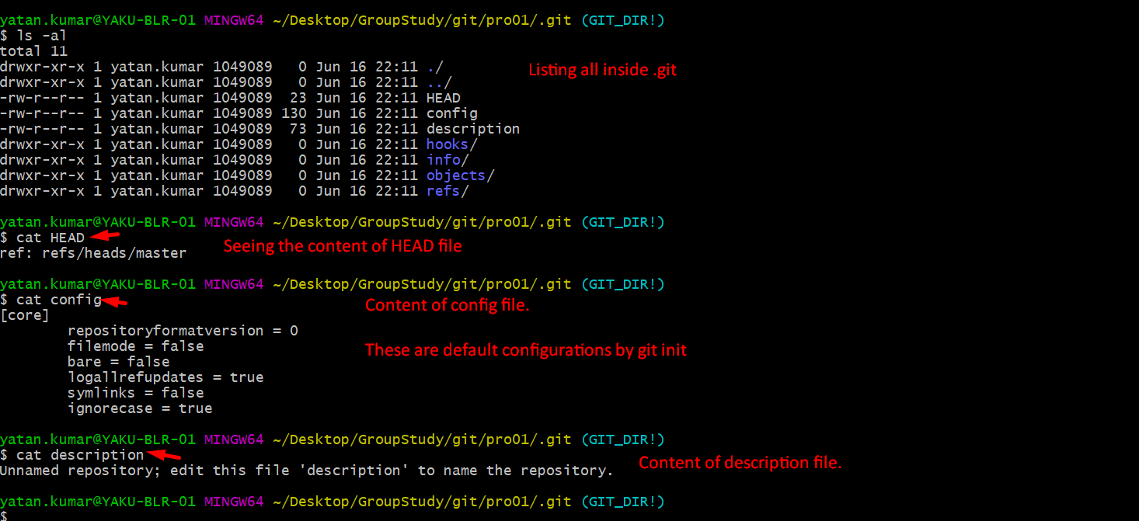
7. 